MONTGOMERY COLLEGE, ROCKVILLE

Engineering Department

ENEE 222 – Elements of Discrete Signal Analysis

Fall 2015

You must SHOW ALL WORKING for FULL CREDIT

Test 3

- (40) Consider the figure below:

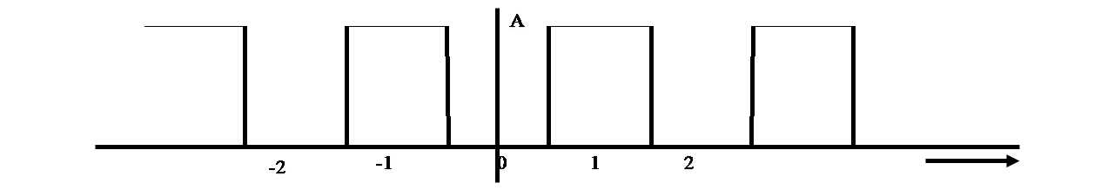

Note:
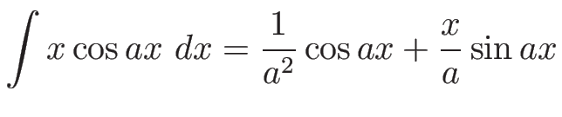
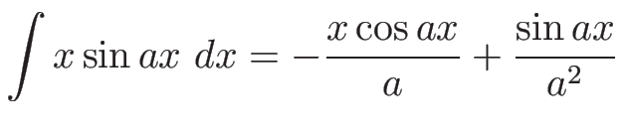
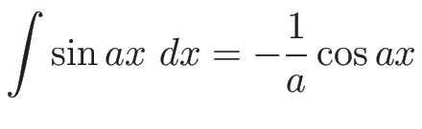
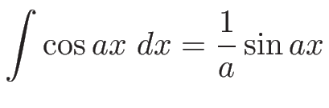

Answer the following questions

DC Yes____ ao = ? No_____ ao = 0

Symmetry
Even____ an = ? bn = 0
Odd____ an = 0 bn = ?
Even & Odd____ an = ? bn = ?

Halfwave symmetry
Yes_____ only odd harmonics
No______ all harmonics

Discontinuities
Yes_____ falls off as 1/n
No______ falls off as 1/n2

Note ? means find that variable.
Comment on the general form of the Fourier series coefficients [an and/or bn.]

Calculate the Fourier Series coefficients [an and/or bn.] and write the Fourier Series expression for f(t). Comment on your prediction

- (30)Consider the signal s = [1 2 3 4 3 2]
  - Determine the least-squares approximation s^ of based on v⁽¹⁾, v⁽³⁾ and v⁽⁵⁾
  - Compute the squared approximation error ||s^ - s||²

- (30) An eight-point real-valued signal s has DFT given by S = [5 x1 4j -3-3j 1 x2 x3 1-j]
  - Compute s[0] - s[1] + s[2] - s[3] + s[4] - s[5] + s[6] - s[7] using one entry of X only.
  - Determine the values of x1, x2, and x3.
  - Compute the amplitude and phase spectra of s, displaying each as a vector.
  - Express s[n] as a linear combination of five real-valued sinusoids.

- Consider a real-valued sinusoid given by:

- Which Fourier frequencies (for an eight-point sample) are present in the signal s? (you must show all working for full credit!)
- Determine the amplitude spectrum of x, displaying your answer in the form [A₀ A₁ A₂ A₃ A₄ A₅ A₆ A₇]]^{T}. (you must show all working for full credit!)
- Determine the phase spectrum of x, displaying your answer in the form [φ₀ φ₁ φ₂ φ₃ φ₄ φ₅ φ₆ φ₇]^{T} (you must show all working for full credit!)
- Determine the DFT, S[n], of the signal, using (b) and (c) above

